Multi SIM card aggregation router
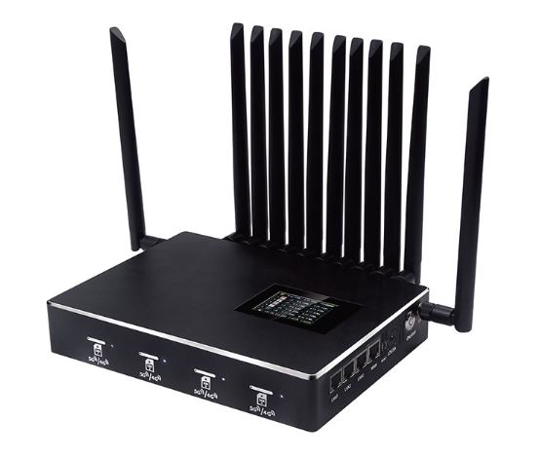
- Product Overview

The QC-R1 series multi card aggregation router is equipped with multiple 4G/5G communication modules, supporting the simultaneous insertion of SIM cards from different operators. It aggregates the bandwidth of multiple internet links through cloud servers, improves the uplink and downlink network bandwidth in mobile environments, reduces mobile network signal blind spots, lowers network latency, and enhances network availability.

- Product Parameters

project | technical parameter
edition | R1-G44 | R1-G5143 | R1-G5242
Communication Module | 4G*4 | 5G+4G*3 | 5G*2+4G*2
Gigabit LAN port | 2 | 3 | 3
Gigabit WAN port | 1
SIM card hot swap | support
display screen | Display battery level, module status, signal strength, carrier, and real-time network speed
WIFI | Supports 2.4G/5G dual-band
Battery life | Built-in lithium battery, battery life ≥7 hours
quick charge | support
other | Customizable standard 1U rack version

- Usage scenarios
Multi carrier card routers are the ultimate tool for solving network needs in scenarios of "mobile, temporary, high reliability, and no coverage".
Improving bandwidth: By load balancing, network traffic is distributed across multiple links, and the total export bandwidth is close to the sum of the bandwidths of each link, making it suitable for downloading, watching high-definition videos, and more.
Network redundancy and high availability: Through fault switching, when a SIM card is in a network with weak signal or no service, the traffic is automatically switched to other normal SIM card networks, greatly improving the reliability of the network.
Intelligent routing: Advanced devices can intelligently select the optimal network path to transmit data based on preset strategies such as signal strength, network latency, and data usage.
High flexibility: not constrained by network cables, as long as there is a signal from the operator, it can quickly establish a network.

